# Challenge 5 – Bus Booking Automation

Challenge seemed easy at first since I have made many data scrapping scripts using selenium in python.

I started off with first opening the website and noting down the html ids of all the required elements on the website since we need them to access that field from selenium library.

Added LDAP and Email password to env variables to protect them.

Program Flow is as described:

1. Launched website, added roll and pass, logged in.
2. Redirected to bus booking link (by passing the quick links and then selecting bus booking, since it was itself a redirect).
3. Filling Date and selecting route from dropdown.
4. Waiting for a second to let the site refresh to pull the timmings and selected schedule from dropdown.
5. Again waited a second to select bus number.
6. Selected seat number and hit the save button.
7. Sent Email to self with details about the bus.

Coming to the problem I had, only problem was filling the date since the cursor of the keyboard presented itself at the spot where the click has been made. To make it clear, if I click to left of the textfield, it would appear at start, if I click somewhere on the field, it will appear there and If I click and right of the field. It would appear at the very last of the field.

So I had a very brute forced way to solve it, I just sent left arrow key command 10 times to bring the cursor to very start and then input the date. And hence the program was up and running.

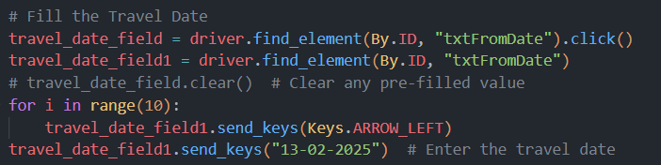

Now coming to booking the bus just when the booking opens and to avoid polling it repeatedly. I spent considerable amount of time analyzing the websites code in search of any api call it might be making which is returning whether the bus can be booked or not. I found that there was no such logic. Then I thought it to be static logic of a fixed interval between the dates like a fortnight or 15 days gap.   
I performed a 2 days experiment to figure out the time delta and turns out there Is no static time delta to bus booking page. I again discussed with Panpaliya telling about the problem and he said that question was intended to do with 15 days gap only (which can be done with python) and I proved that the time delta is dynamic and not fixed. So he asked me to leave it there and then and so did I.

If there was a static time delta to exit then it can easily be incorporated in the python code by going 15 days back from booking date (date when the booking starts) and then setting the program to sleep till that date and time. (put the code for this logic as well but commented)

Rest of the code was completely functional. (I also sent booking mail to Dwivedi bhaiya for fun)

